Unit 1 Final Name:___________________________
Written Response Date:____________________________

Task #1: Open up a new WORD doc.
Make sure that you put your name and response question on your title page.
Task #2: You will need to open the following Prezi that we covered in class: (OPEN BOOK TEST)
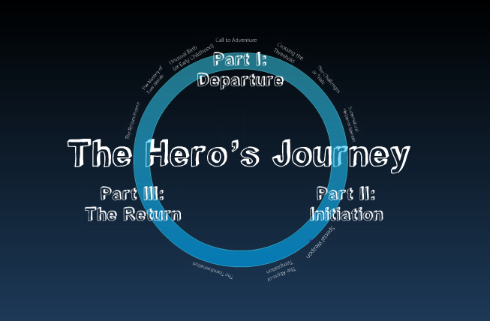
*Use this lecture material to guide your responses.
Copy and paste this address into your web browser:
http://prezi.com/k6bxm9naoxbb/the-heros-journey/?kw=view-k6bxm9naoxbb&rc=ref-16399729
(Be sure to hit the small “full-screen” button on the bottom right-hand corner of the Prezi for optimum viewing.)

Task #2: Choose and respond to one of the following written response questions:

Written Response #1 IRON MAN
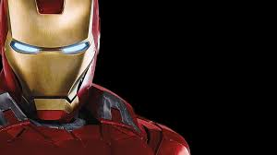
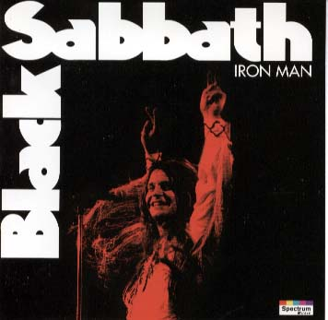

“Iron Man” by Black Sabbath
Song Summary
The lyrics concern a champion of humanity who travels Time, presumably to ensure "the future of Mankind" — his original mission was to save our species. We learn that this champion unfortunately encountered a "Great Magnetic Field," turning him into steel and rendering him immobile. He has been in this state for so long that humanity has forgotten his original identity and his original mission. Rather than hailing him as a hero, the human race now regards him as an oddity, little more than an enigmatic statue from another age. The first few lines of the song are the musings of curious passersby, wondering if he's alive or dead, if he can see, if he can move, et cetera. Although the exact nature of his transformation is not elucidated, we know that Iron Man is not solid steel, but is in perhaps an organic/inorganic state, in which he can still perceive the physical world and can still think, but cannot take action. Because humanity has forgotten everything he's done for them in the past, Iron Man has grown increasingly bitter and plans his vengeance upon the ungrateful human race. Evidently, his bizarre state of suspended animation is only temporary — when Iron Man regains his freedom to move, he "kills the people he once saved" in a dreadful manner.
Song Lyrics
"Iron Man"
Has he lost his mind?
Can he see or is he blind?
Can he walk at all,
Or if he moves will he fall?
Is he alive or dead?
Has he thoughts within his head?
We'll just pass him there
why should we even care?
He was turned to steel
in the great magnetic field
When he travelled time
for the future of mankind
Nobody wants him
He just stares at the world
Planning his vengeance
that he will soon unfurl
Now the time is here
for Iron Man to spread fear
Vengeance from the grave
Kills the people he once saved
Nobody wants him
They just turn their heads
Nobody helps him
Now he has his revenge
Heavy boots of lead
fills his victims full of dread
Running as fast as they can
Iron Man lives again!

Response Question:
Use your prior knowledge, notes from Greek myths covered in class, and the Prezi lecture provided, to determine whether Ozzy Osbourne’s “Iron Man” follows the “Hero’s Journey”. Is this song effective in delivering the key characteristics of what a hero endures? Provide examples from the summary, song lyrics, and Prezi lecture.
Checklist: I used examples from the Prezi in my response YES/NO
I used example from the song in my response YES/NO
I even connected this material to stories we covered in class! YES/NO
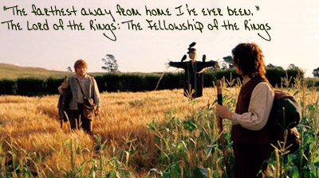
Written Response #2:

YouTube link: http://www.youtube.com/watch?v=zIL_05Eh7Pc
Movie Script link: http://www.tk421.net/lotr/film/fotr/08.html

Response Question:
Use your prior knowledge, notes from Greek myths covered in class, and the Prezi lecture provided, to illustrate how this scene from The Fellowship of the Ring exemplifies the types of challenges and hurdles that heroes face. In your response you should consider the many obstacles faced by heroes in Greek mythology, modern film, and music. Please be specific! Use quotes when possible.
Why are these obstacles important to the hero’s development? What can we, as ordinary individuals, learn from this?

Checklist: I used examples from the Prezi in my response YES/NO
I used example from the movie script/YouTube video in my response YES/NO
I even connected this material to stories we covered in class! YES/NO

